EXP 5:Simulation and Performance Evaluation of RFID/NFC-Based Device Identification and IoE Data Integration using Node-RED, MQTT
Objective:
To simulate RFID/NFC-based device identification and integrate the identified device data into a four-layer IoE architecture (Perception, Network, Middleware, Application) using MQTT messaging and a Node-RED style flow, and to evaluate it using tag read rate, identification rate, MQTT delivery rate and end-to-end valid data rate.
Procedure:
- Create a registry of 80 registered RFID/NFC tags (TAG001 to TAG080) and scan 100 tags in total: 80 registered and 20 unregistered (UNKNOWN081 to UNKNOWN100).
- Perception layer: simulate each tag read with a 95% read success probability, assign a random RSSI between -75 and -30 dBm to every successful read, and identify the tag against the registry.
- Network layer: publish each successful read as a JSON message on the MQTT topic ioe/rfid/device, with a 98% delivery probability.
- Middleware layer: accept delivered messages whose device ID is in the registry and reject messages from unknown IDs.
- Application layer: store accepted messages as cloud dashboard records.
- Compute the performance metrics and plot the data flow, identification results, MQTT delivery and RSSI distribution.
Program:
# ============================================================
# RFID/NFC-BASED DEVICE IDENTIFICATION AND IoE DATA INTEGRATION
# Four-Layer IoE Architecture using MQTT and Node-RED Simulation
# Google Colab compatible
# ============================================================

import numpy as np
import pandas as pd
import matplotlib.pyplot as plt
import random
import json
from datetime import datetime

# Reproducible simulation
np.random.seed(42)
random.seed(42)

# -------------------- 1. CONFIGURATION -----------------------

NUM_DEVICES = 100
READ_SUCCESS_RATE = 0.95
MQTT_DELIVERY_RATE = 0.98

# Registered RFID/NFC devices
device_registry = {
f"TAG{i:03d}": f"Device_{i:03d}"
for i in range(1, 81)
}

print("=" * 65)
print(" RFID/NFC-BASED IoE DEVICE IDENTIFICATION SIMULATION")
print("=" * 65)

# -------------------- 2. LAYER 1: PERCEPTION -----------------

perception_data = []

for i in range(NUM_DEVICES):

# 80% registered devices, 20% unregistered devices
if i < 80:
tag_id = f"TAG{i+1:03d}"
else:
tag_id = f"UNKNOWN{i+1:03d}"

read_success = random.random() < READ_SUCCESS_RATE

if read_success:
rssi = np.random.randint(-75, -30)
identified = tag_id in device_registry
device_name = device_registry.get(tag_id, "Unknown Device")
else:
rssi = np.nan
identified = False
device_name = "Read Failed"

perception_data.append({
"Device_ID": tag_id,
"Device_Name": device_name,
"Read_Success": read_success,
"RSSI_dBm": rssi,
"Identified": identified
})

perception_df = pd.DataFrame(perception_data)

successful_reads = int(perception_df["Read_Success"].sum())
identified_devices = int(perception_df["Identified"].sum())

print("\nLAYER 1: PERCEPTION")
print("Total tag scan attempts:", NUM_DEVICES)
print("Successful tag reads:", successful_reads)
print("Registered devices identified:", identified_devices)

# -------------------- 3. LAYER 2: NETWORK / MQTT -------------

mqtt_messages = []
transmitted = 0
delivered = 0

for _, row in perception_df.iterrows():

if not row["Read_Success"]:
continue

transmitted += 1
mqtt_success = random.random() < MQTT_DELIVERY_RATE

message = {
"device_id": row["Device_ID"],
"device_name": row["Device_Name"],
"rssi_dbm": int(row["RSSI_dBm"]),
"timestamp": datetime.now().isoformat(timespec="seconds"),
"topic": "ioe/rfid/device",
"mqtt_status": "Delivered" if mqtt_success else "Lost"
}

mqtt_messages.append(message)

if mqtt_success:
delivered += 1

print("\nLAYER 2: NETWORK")
print("MQTT messages published:", transmitted)
print("MQTT messages delivered:", delivered)
print("MQTT messages lost:", transmitted - delivered)

# -------------------- 4. LAYER 3: MIDDLEWARE -----------------

processed_messages = []
rejected_messages = []

for message in mqtt_messages:

if message["mqtt_status"] != "Delivered":
continue

if message["device_id"] in device_registry:
message["processing_status"] = "Accepted"
processed_messages.append(message)
else:
message["processing_status"] = "Rejected - Unknown ID"
rejected_messages.append(message)

print("\nLAYER 3: MIDDLEWARE")
print("Valid messages processed:", len(processed_messages))
print("Unknown devices rejected:", len(rejected_messages))

# -------------------- 5. LAYER 4: APPLICATION ----------------

dashboard_df = pd.DataFrame(processed_messages)

if not dashboard_df.empty:
dashboard_df["Timestamp"] = pd.to_datetime(
dashboard_df["timestamp"]
)

dashboard_df["Sequence"] = np.arange(
1, len(dashboard_df) + 1
)

print("\nLAYER 4: APPLICATION")
print("Dashboard records:", len(dashboard_df))
print("Unique registered devices:",
dashboard_df["device_id"].nunique()
if not dashboard_df.empty else 0)

# -------------------- 6. PERFORMANCE EVALUATION --------------

identification_accuracy = (
identified_devices / NUM_DEVICES
) * 100

read_rate = (successful_reads / NUM_DEVICES) * 100

mqtt_delivery_rate = (
delivered / transmitted * 100
if transmitted > 0 else 0
)

end_to_end_rate = (
len(processed_messages) / NUM_DEVICES
) * 100

print("\n" + "=" * 65)
print(" PERFORMANCE RESULTS")
print("=" * 65)
print(f"RFID read success rate : {read_rate:.2f}%")
print(f"Registered identification : {identification_accuracy:.2f}%")
print(f"MQTT delivery rate : {mqtt_delivery_rate:.2f}%")
print(f"End-to-end valid data rate : {end_to_end_rate:.2f}%")

# -------------------- 7. DISPLAY MQTT MESSAGE ----------------

print("\nSAMPLE MQTT JSON MESSAGE")
if mqtt_messages:
print(json.dumps(mqtt_messages[0], indent=4))

# -------------------- 8. DASHBOARD TABLE ---------------------

print("\nCLOUD DASHBOARD - SAMPLE RECORDS")
if not dashboard_df.empty:
display(
dashboard_df[
["device_id", "device_name", "rssi_dbm",
"mqtt_status", "processing_status"]
].head(10)
)
else:
print("No valid messages reached the dashboard.")

# -------------------- 9. PERFORMANCE GRAPHS ------------------

fig, axes = plt.subplots(2, 2, figsize=(14, 9))

# Graph 1: IoE layer data flow
layer_names = [
"Tag scan",
"MQTT publish",
"MQTT delivery",
"Middleware accepted",
"Dashboard"
]

layer_counts = [
NUM_DEVICES,
transmitted,
delivered,
len(processed_messages),
len(dashboard_df)
]

axes[0, 0].bar(layer_names, layer_counts)
axes[0, 0].set_title("Data Flow Through Four IoE Layers")
axes[0, 0].set_ylabel("Number of Records")
axes[0, 0].tick_params(axis="x", rotation=25)
axes[0, 0].grid(axis="y", alpha=0.3)

# Graph 2: Device identification results
identification_counts = [
identified_devices,
int(perception_df["Read_Success"].sum()
- perception_df["Identified"].sum()),
NUM_DEVICES - successful_reads
]

axes[0, 1].bar(
["Registered IDs", "Unknown IDs", "Read failures"],
identification_counts
)
axes[0, 1].set_title("RFID/NFC Identification Results")
axes[0, 1].set_ylabel("Number of Devices")
axes[0, 1].grid(axis="y", alpha=0.3)

# Graph 3: MQTT transmission performance
mqtt_counts = [
delivered,
transmitted - delivered
]

axes[1, 0].bar(
["Delivered", "Lost"],
mqtt_counts
)
axes[1, 0].set_title("MQTT Message Delivery Performance")
axes[1, 0].set_ylabel("Number of Messages")
axes[1, 0].grid(axis="y", alpha=0.3)

# Graph 4: RSSI distribution for successfully read tags
valid_rssi = perception_df["RSSI_dBm"].dropna()

axes[1, 1].hist(
valid_rssi,
bins=10,
edgecolor="black"
)
axes[1, 1].set_title("RFID/NFC Signal Strength Distribution")
axes[1, 1].set_xlabel("RSSI (dBm)")
axes[1, 1].set_ylabel("Frequency")
axes[1, 1].grid(axis="y", alpha=0.3)

plt.tight_layout()
plt.show()

# -------------------- 10. FINAL SUMMARY ----------------------

print("\nSIMULATION COMPLETED SUCCESSFULLY")
print("Perception -> Network -> Middleware -> Application")
print("Device identification and simulated MQTT data flow evaluated.")
print("Note: All results are simulated, not measured from hardware.")

Output:
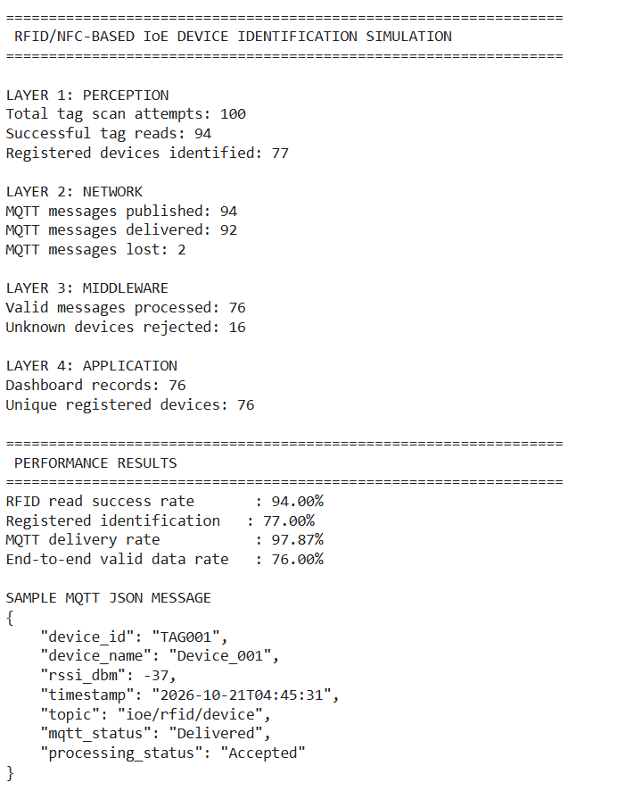
Fig. 1: Console output of the simulation (four layers and performance results)
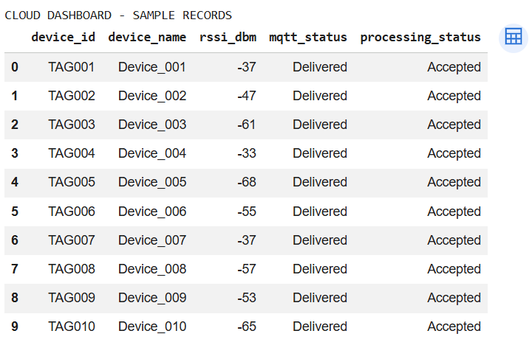
Fig. 2: Cloud dashboard - sample records
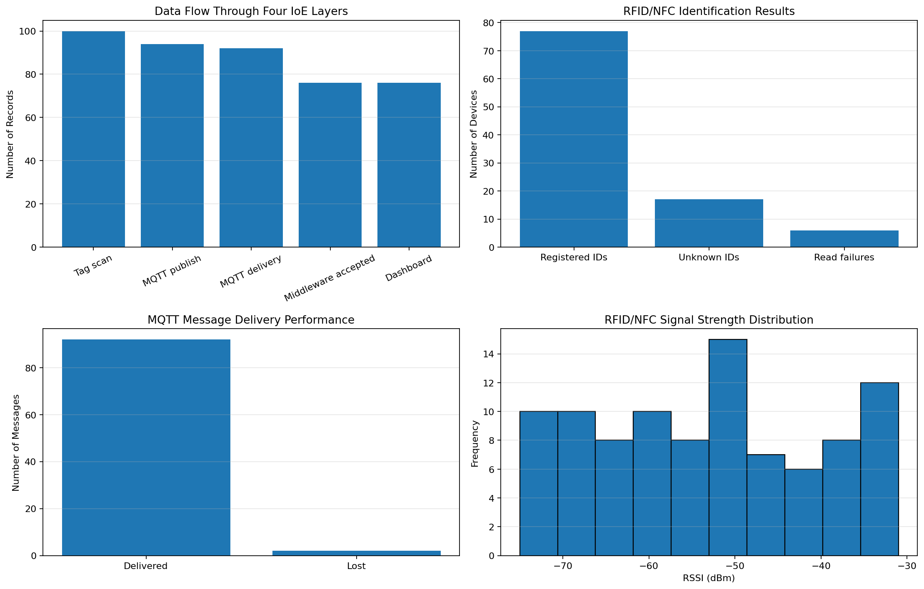
Fig. 3: Performance graphs (data flow, identification, MQTT delivery, RSSI distribution)
Results:
IoE layer | Measure | Count
Perception | Tag scan attempts | 100
Perception | Successful tag reads | 94
Perception | Registered devices identified | 77
Network | MQTT messages published / delivered / lost | 94 / 92 / 2
Middleware | Valid messages processed / unknown rejected | 76 / 16
Application | Dashboard records (unique devices) | 76 (76)

Metric | Value
RFID read success rate | 94.00% (94 of 100)
Registered identification rate | 77.00% (77 of 100)
MQTT delivery rate | 97.87% (92 of 94)
End-to-end valid data rate | 76.00% (76 of 100)

Of the 100 scans, 6 failed to read and 17 of the successful reads were unregistered tags. Two MQTT messages were lost (one registered, one unknown), so 76 registered devices (of 77 identified) and 16 unknown devices reached the middleware. The 16 unknown IDs were rejected, and the remaining 76 valid messages appeared on the dashboard. RSSI values are spread across -75 to -30 dBm.
Result:
The simulated four-layer IoE system identified registered RFID/NFC devices and delivered their data end to end with a 76.00% valid data rate. The read success rate (94.00%) and MQTT delivery rate (97.87%) were close to the configured 95% and 98%, and the middleware correctly rejected every unknown tag, which shows that registry-based validation protects the dashboard from unregistered devices. The main losses came from unregistered tags (20% of the scanned set) and read failures rather than from the network. All values are simulated, not measured from hardware.

